**PRACTICAL 7**

**AIM:**

Case Study: Project Management using ASANA tool.

**BACKGROUND KNOWLEDGE REQUIRED:**

Basic knowledge and understanding of Software Engineering.

**THEORY:**



Fig 5.1 Asana Logo

Asana is the easiest way for you and your team to track your work.

**Functions Available:**

* Create project space.
* Add and assign tasks for the project.
* Add details for each task (Image/PDF/etc.).
* Communicate task related updates on the same pane.

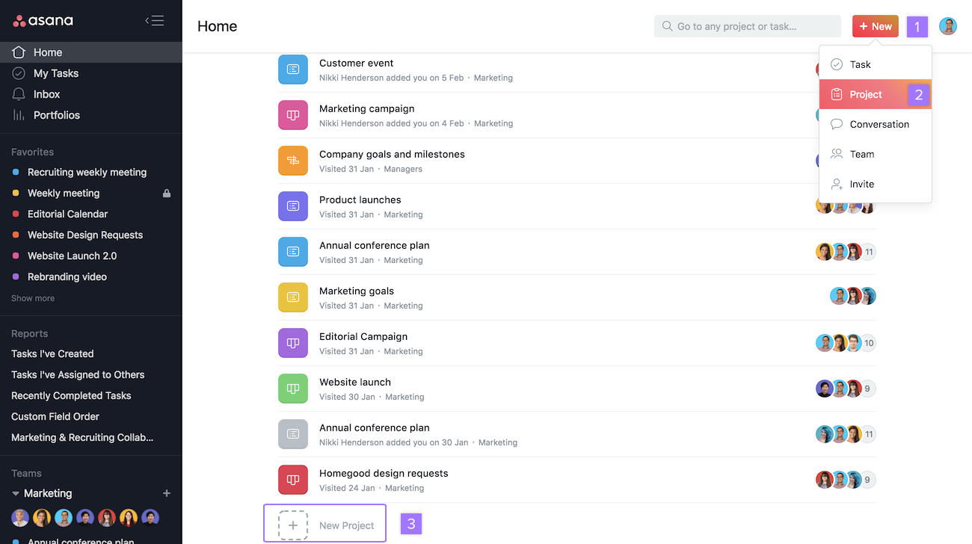

Fig 5.2 Asana Portal

**Time Costing:**

Calculate time devoted to sprint tasks by putting costs in square brackets at the start of a task name. First, turn on the Add up Numbers in Brackets hack in My Profile Settings, under the Hacks tab. To see the time totals, multi-select tasks whose names start with a number in [brackets] and you will see the sum in the right pane.

You can also set up a Harvest integration to see how your time estimates compare to actual time spent. Forecast time more accurately and know the average time spent on tasks you do frequently for future planning.

**Case Study:**

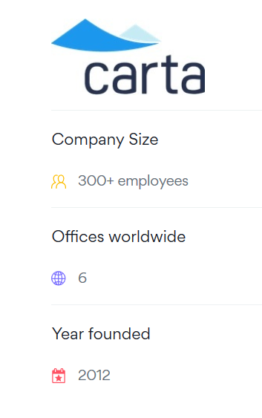

# **How Carta keeps their fast-growing team in the know with Asana:**

A fast-growing company with a start-up mind set, Carta is always evolving. New employees are hired as rapidly as new features are released, creating an exciting work environment and a product customers love. However, constant change can make it difficult for employees to keep track of everything that’s happening.

Jina Kim, who currently works in compliance, has experienced first-hand the fast-paced growth at Carta, an SEC-registered transfer agent that helps public and private companies issue and manage securities. In her few years at the company as an early employee, Jina has had the opportunity to build out several teams. Her current role requires her to work very cross-functionally since compliance impacts—and is impacted by—many teams at Carta.

With change as the only constant and an ever-growing number of employees, it’s crucial that Jina and her team maintain transparency so no one is thrown off course by changes to product or procedure.

This transparency is also key to Carta’s “always be helpful” mentality, since it’s easier for team members to help one another and the customers they serve when they’re always on the same page.

### **With constant growth, Process is key:**

Anyone who has ever worked at a fast-growing company can sympathize with growing pains. Excited about growth but also wanting to stay nimble, Jina and the Carta team realized early on that they’d need a process—and a tool—for scaling efficiently.

“The big picture is that we’re a growing company,” explains Jina. “We’re 300 people and growing, but we still have that start-up mentality.”

For Carta, that start-up mentality means maintaining the seamless coordination of a small, tight-knit team. This is no small task: As the company grows in size, the potential for missing an important update or losing track of what other teams are working on also grows. This is all the more important for ensuring that new product features are compliant.

“There are so many things that are constantly changing and communication is really the key,” says Jina. “If, for example, the support team comes in one day and they realize that something has changed in the product overnight, they need a way to find out.”

To keep up with the pace of change, Jina and her team rely on Asana to track who’s working on what, coordinate on work across business units, and most importantly, understand what product features are going out to market at any given time.

Teams at Carta also use Asana to create and run routine processes so that everyone knows what to expect and has the information they need to effectively do their jobs.

### **Tracking day-to-day work:**

To achieve transparency at a more granular level and [maintain regular communication](https://asana.com/uses/team-communication), members of the business, engineering, and product teams attend daily cross-functional “morning meetings” to discuss work. They use Asana to manage morning meeting agendas, which typically consist of what’s being worked on during that week.

“Morning meetings are so important because they involve all the stakeholders. They allow teams to get feedback and to keep track of what everyone is working on,” says Jina. On any given morning, there can be as many as 10 or 12 morning meetings.

For instance, Jina attends the Public Markets morning meeting, which focuses on the product Carta builds for their public company customers. During this meeting, business, engineering and product team members go through their weekly updates.

“For folks outside of the product and engineering teams like me, morning meetings are good because I can get context and I’m able to do my job better. I have more visibility into potential compliance risks and can get involved or follow along where I need to.”

### **With Asana, everyone can see both the granular details of individual projects accountability as well as high-level company progress. Achieving growth through:**

From tracking weekly sprints to asking the CEO anything, Jina and her team use Asana to ensure that everyone has what they need to be the best at their jobs.

Jina explains how this transparency affords them the accuracy they need to make helpful, accurate recommendations to customers. “For the business people, if you’re going to go ahead and sell our software to a customer, you want to be able to say, ‘Hey, here are all the features that we’re working on,’ and be accurate. You don’t want to sell a feature that isn’t being built.”

By holding themselves and each other accountable, Carta has done a rare thing: achieved massive growth while still feeling the energy and speed of their early start-up days.

**CONCLUSION:**

The learning behind this practical was to perform the case and gain the knowledge about Asana Tool and know how to do Project management using asana tool.

**REFERENCES:**

* <https://asana.com/>
* https://en.wikipedia.org/wiki/Asana